

Internal Memorandum

**To:** CIO

**CC:**

**From:**Team A

**Date:** October 21, 2018

**Memo #: 2**

**Re:** Enable and activate firewall

**Good Afternoon,**

**Attached is the firewall rule addition for each computer.**

Windows 2008 - MediaWiki

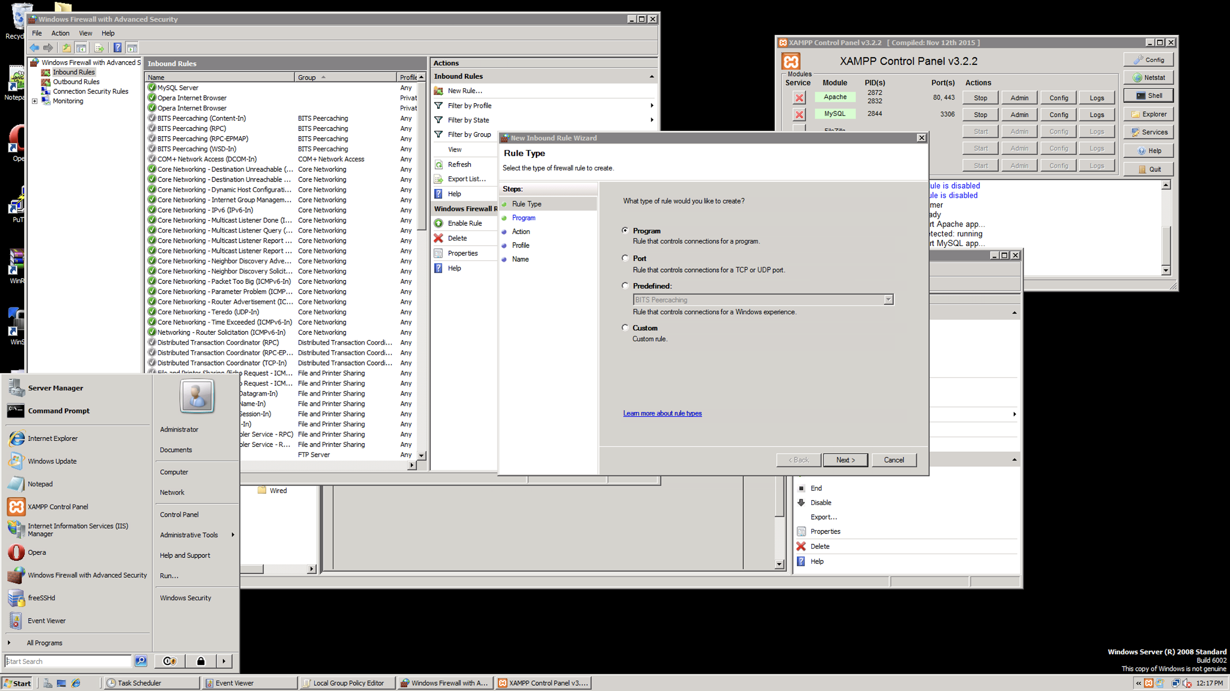

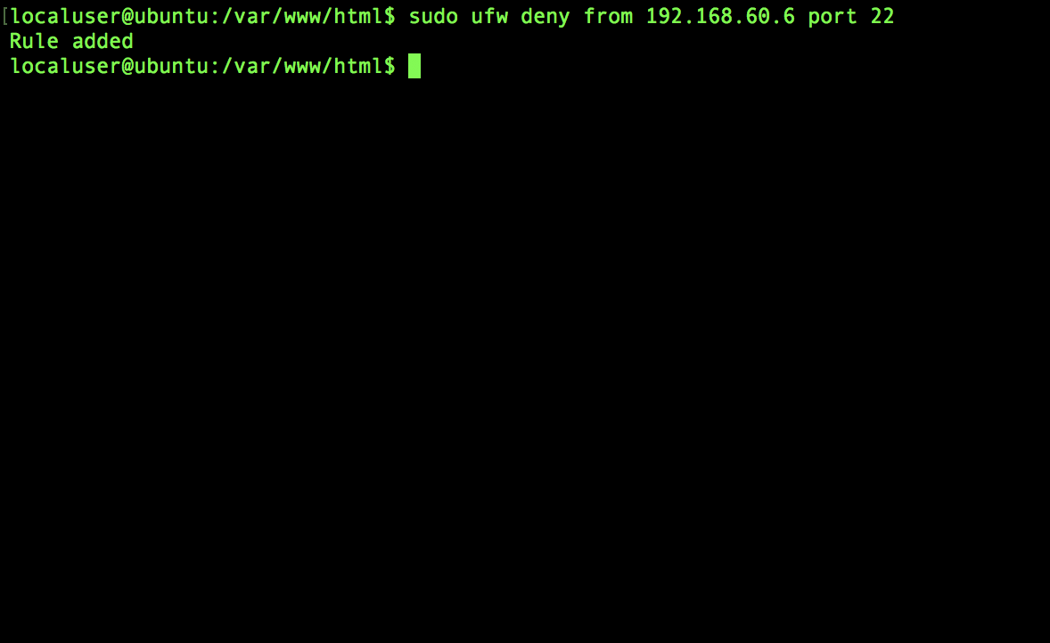

**Figure 3: Windows Server 2008**

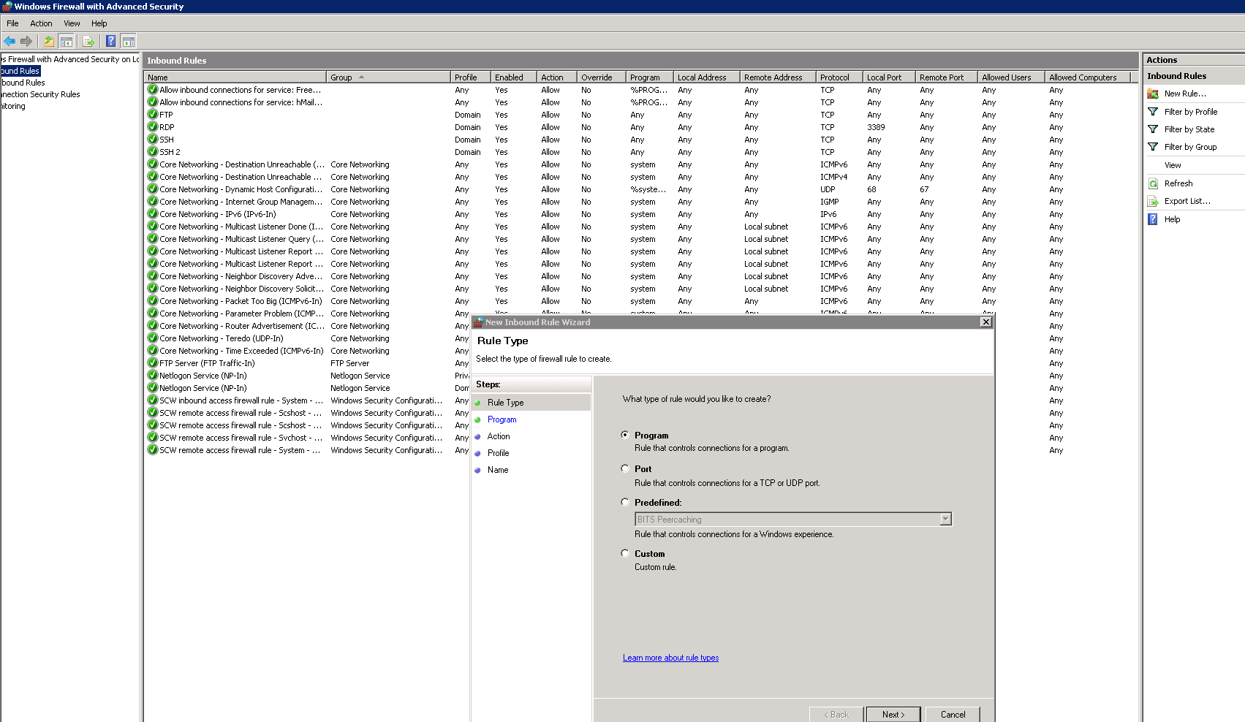

**Figure 4: Windows Server 2012**

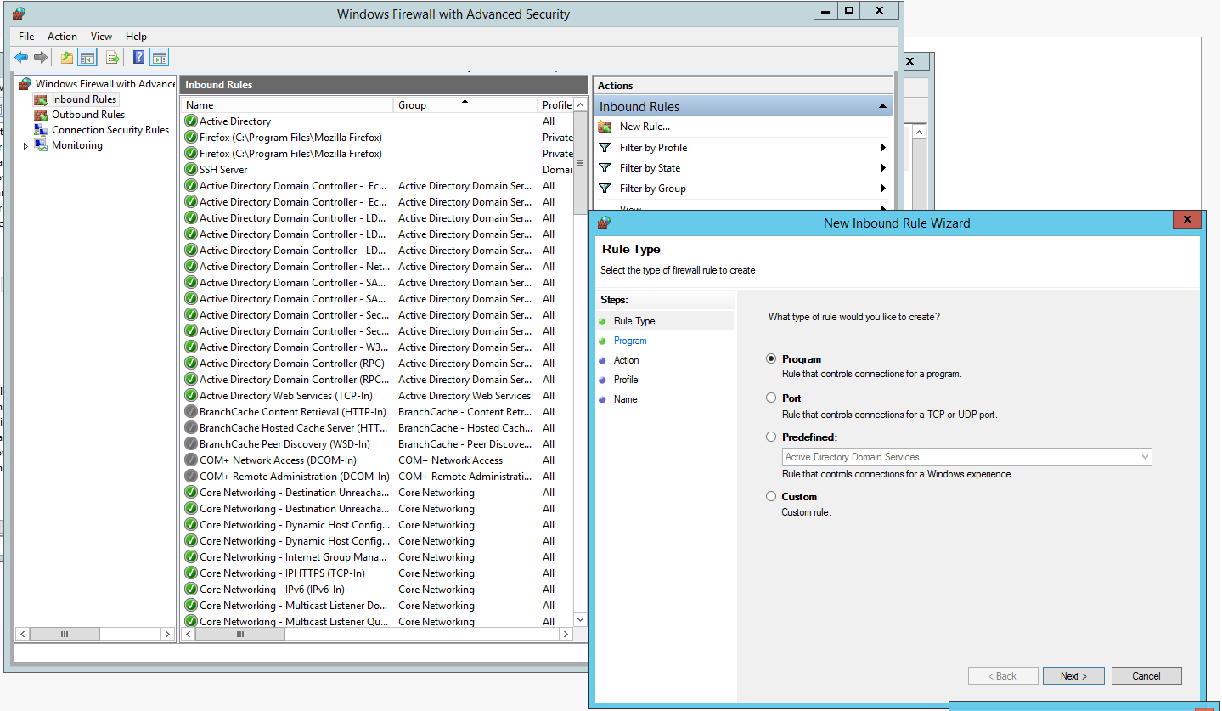

*This document is for the explicit purpose of supporting the 2018 SECCDC Preliminary Qualification Competition. Any similarity to organizations or persons real or imagined is purely coincidental. Do not disclose this document to anyone without the expressed permission of the competition organizers.*

Ubunto - Bind

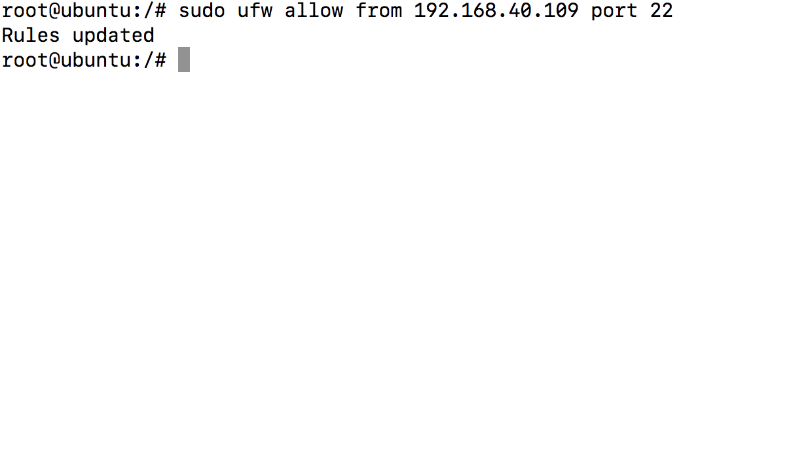

Sincerely,

Team A

*In accordance with HAL Memorandum policy, the entire header must be completed or the recipient may not acknowledge this as an official memorandum. Professional communications methods and decorum must be observed at all times.*